QUE 1 are the html tags and elements the same thing ?

ANS 1 html tags and html elements are not same thing because html tags are building blocks of html page.html elements are components that are used in html page.

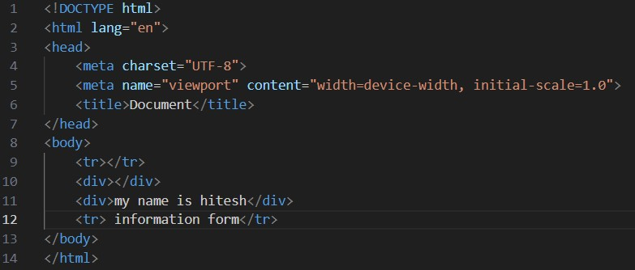

<tr></tr> and <div></div> that are a tags.

Eg <tr></tr>

<div></div>

we can write in tag that called elements

Eg <div> my name is hitesh <div>

<tr> information form </tr>

QUE 2 what are the tags and attritubes in html ?

ANS 2 html tags are used in work starting or closing.

Html attritube are provide the information of html elements.

This are html tags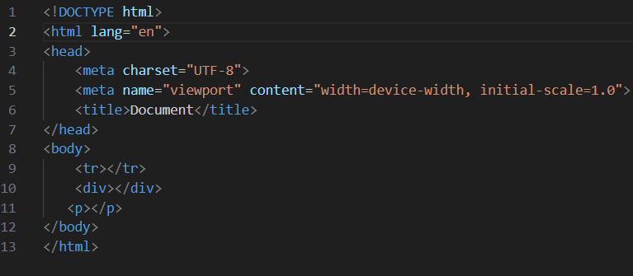

This is html elements

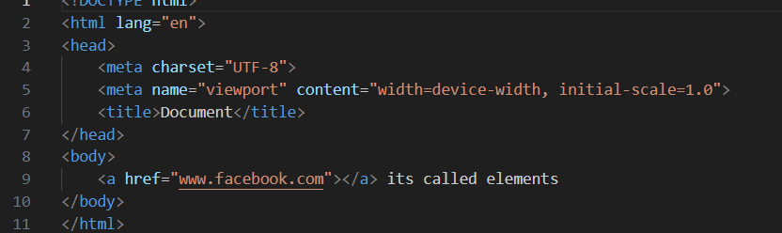

QUE 3 what are void element in html? With example.

ANS 3 an element that has only opning tag they has not closing tag that called void element

<img> tag and <br>

>tag are that tag are only start the tag are not a end so that are avoid element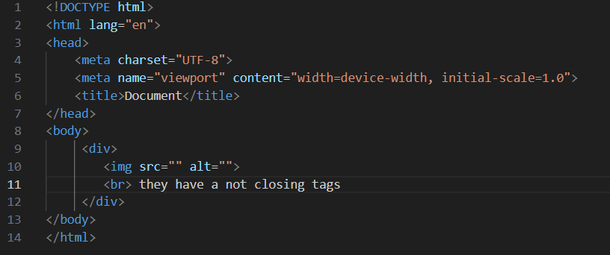

QUE 4what are the html entities? with example.

ANS 4 an html entities are start the (“ “)string and that end the (;)semicolon

When we can a symbolles and picture saw in desktop (output) it called the entities

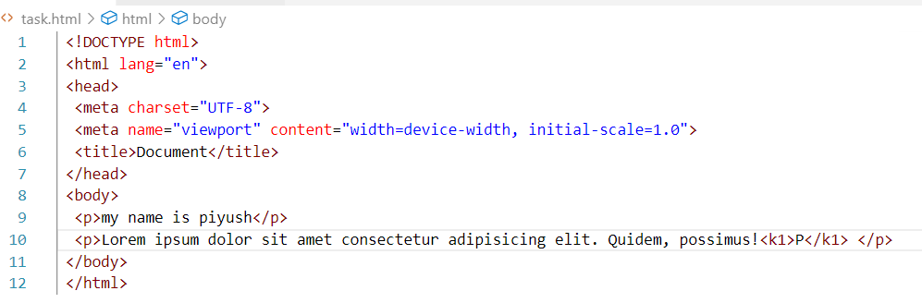

QUE 5 what are the different types of lists in html ? with example.

ANS 5 the html lists are used to the set of group in name value and

Items

There are three types

1 order list

2 unorder list

3 defination list

Order list

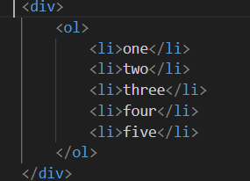

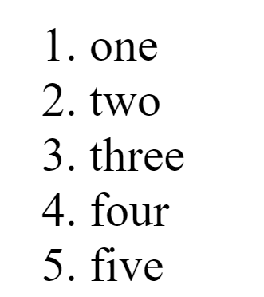

Unorder list

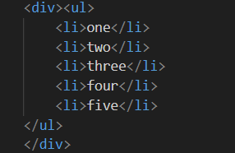

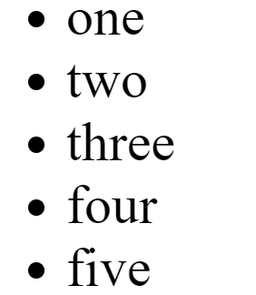

Defination list

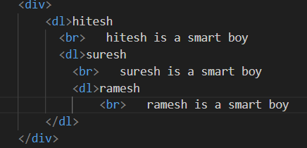

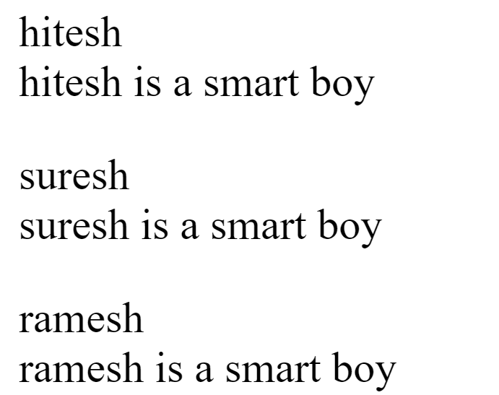

QUE 6 what is the class attritube in html ? with example.

ANS 6 when we can different effect two programme that we used two different class

EG

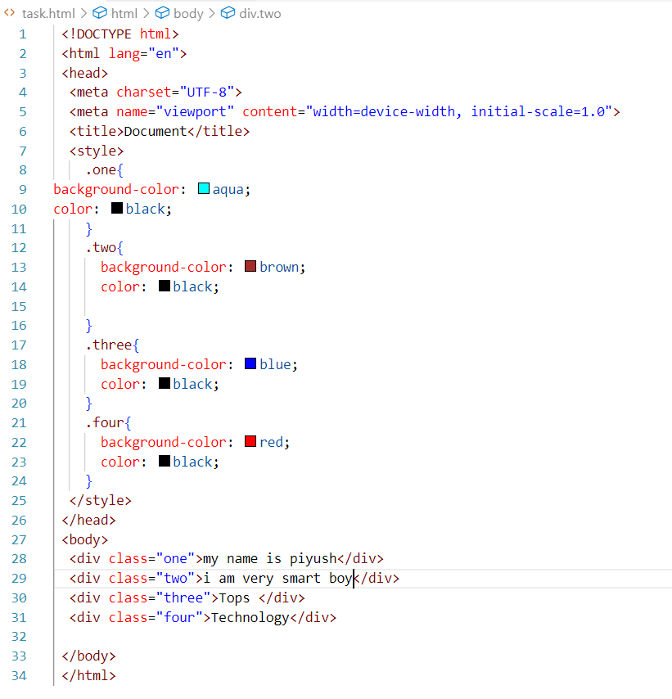

QUE 7 what is the diffrance between “id” attribute and “class” attribute in html ? with example.

ANS 7 a class is a use of multiple html element . while id is a use of one html element.

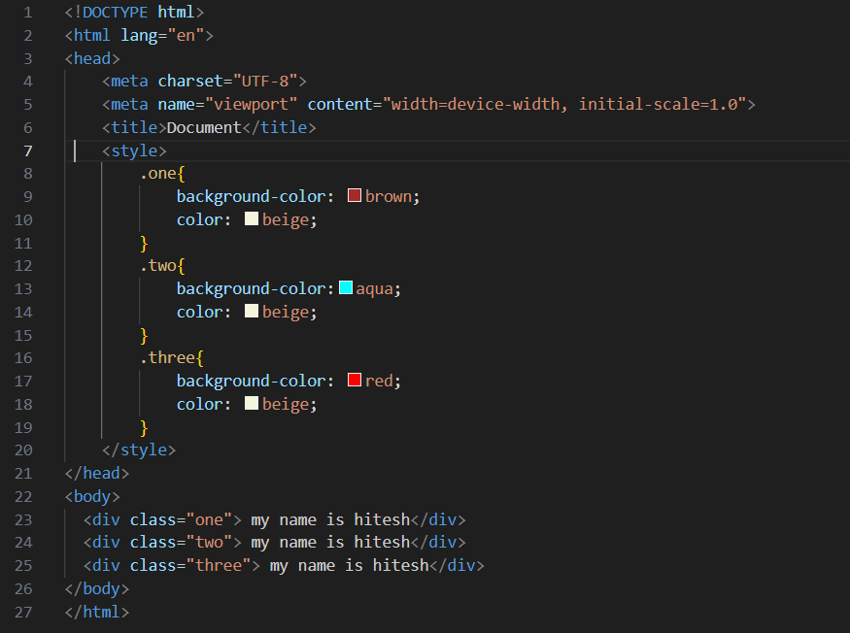

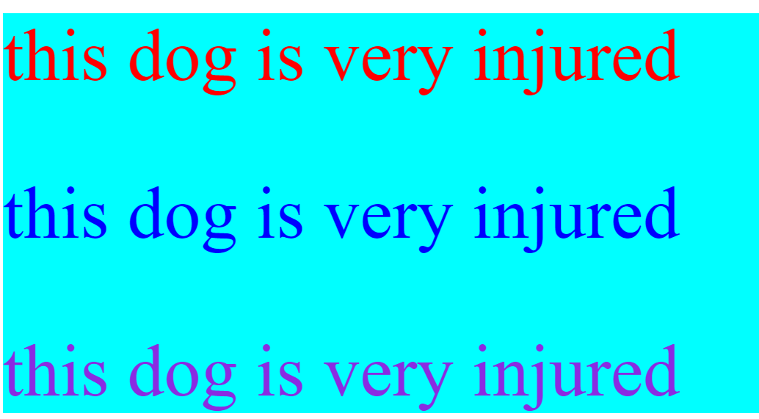

QUE 8 what are the various formatting tags in html ?

ANS 8 formating tags are design to display special type .such as bold italic underline etc.

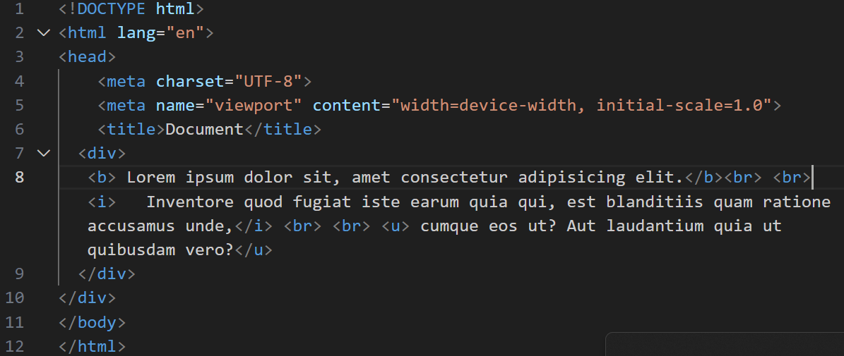

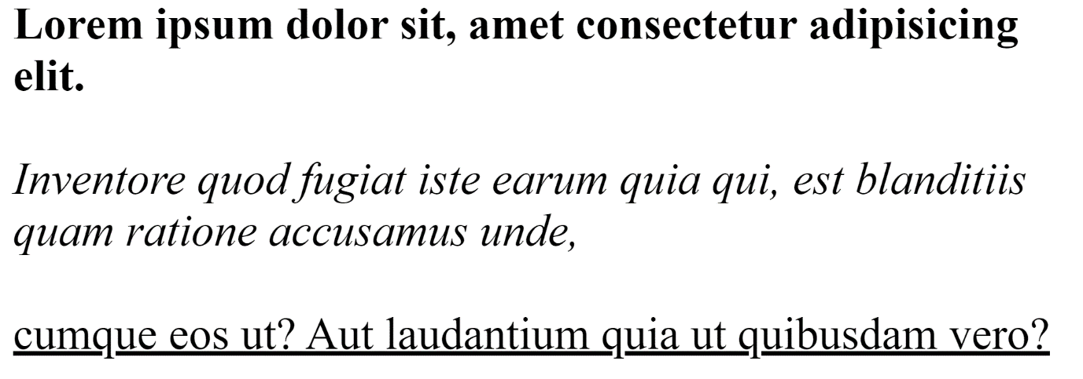

QUE 9 how is cell padding different from cell spacing ? with example.

ANS 9 cell padding is a specifies amount between the border of table and its contents

Cell spacing is a space between the content in table

Normal

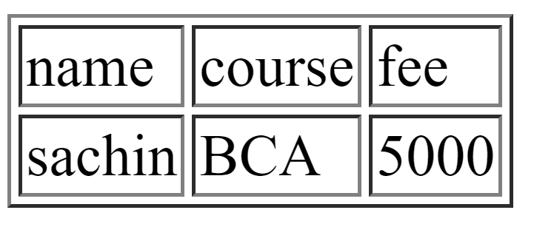

Cell spacing

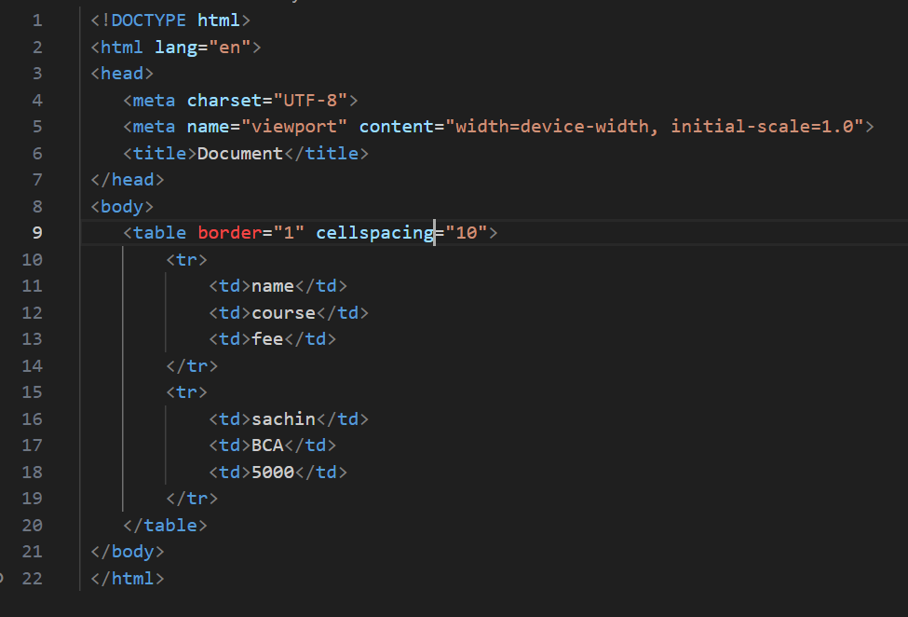

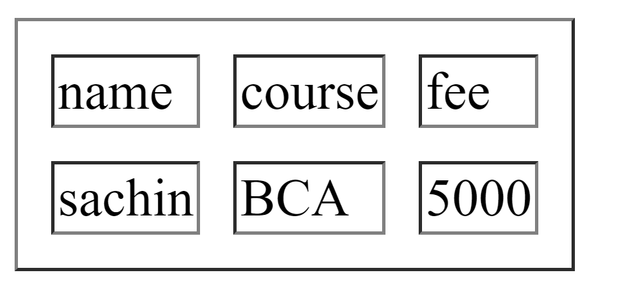

Cell padding

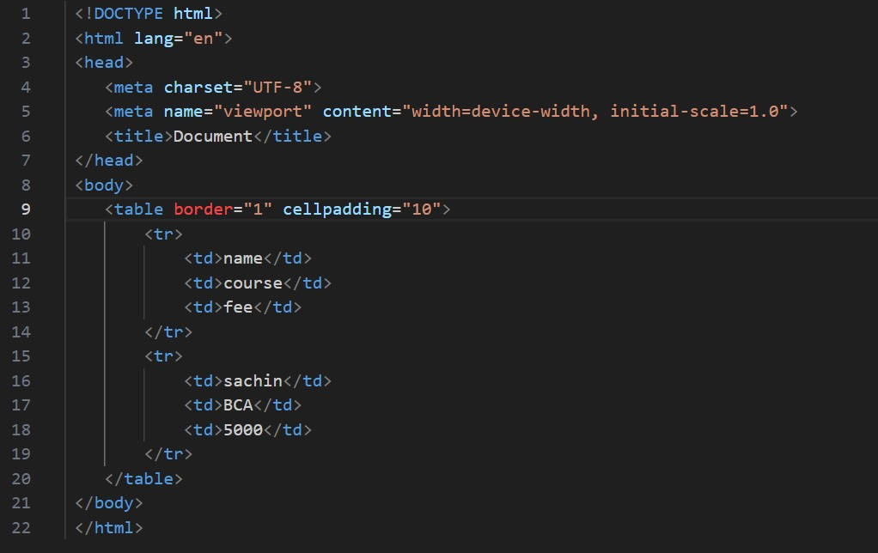

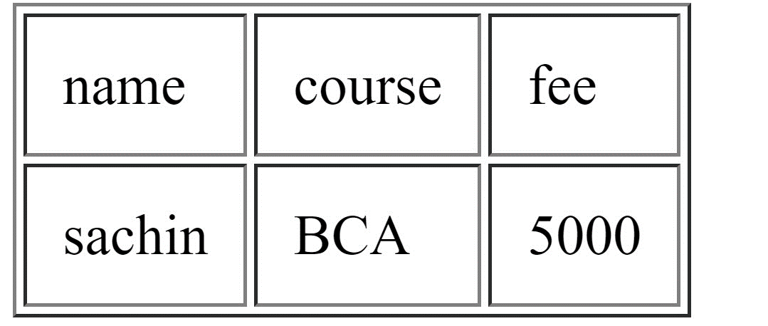­­­

ANS 10 how can we club two or more rows or columns into a single row or column in an html table ? with example.

Using the rowspan and colspan attribute element we club two or more rows or columns into a single row or column in an html table

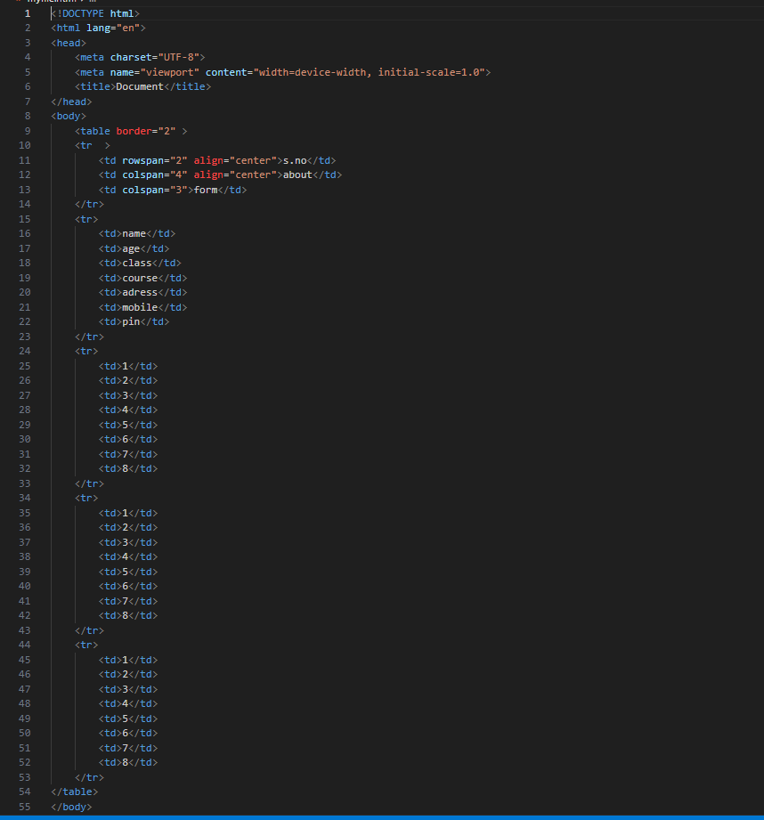

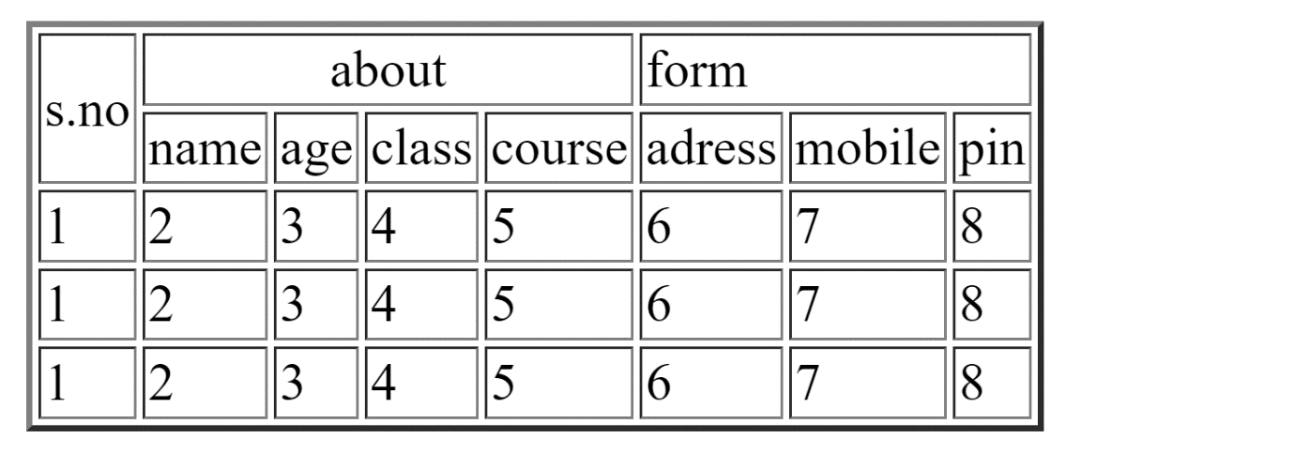

QUE 11 what is the difference between block element and inline element ?

ANS 11 block element cover space left to right as far as it can go .and inline element only cover the space is bounded the tags in html

INLINE ELEMENTS

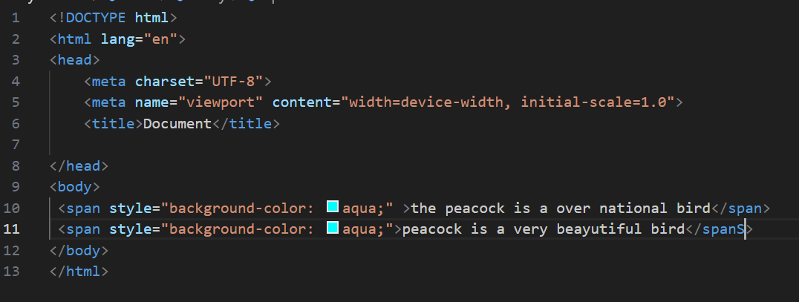



BLOCK ELEMENT

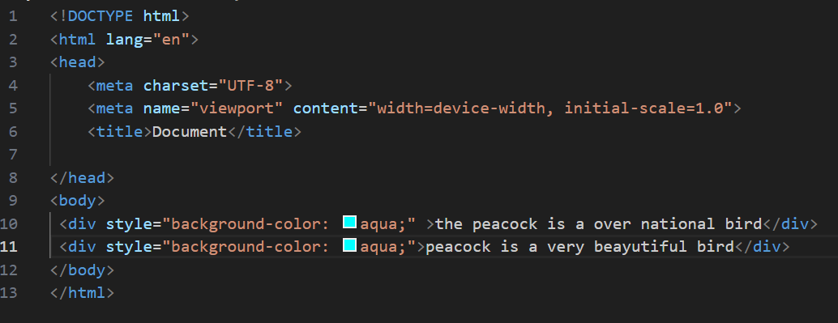

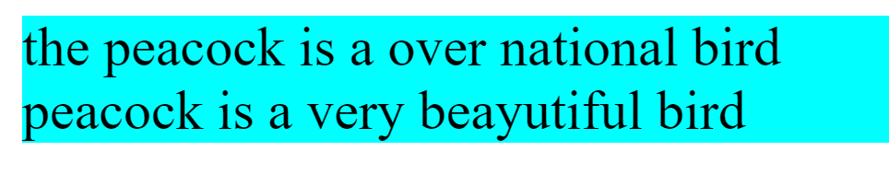

QUE 12 how to create in HYPERLINK in html ? with example.

ANS 12 THE<a> tag is used for hyperlink , which is used one page to another page

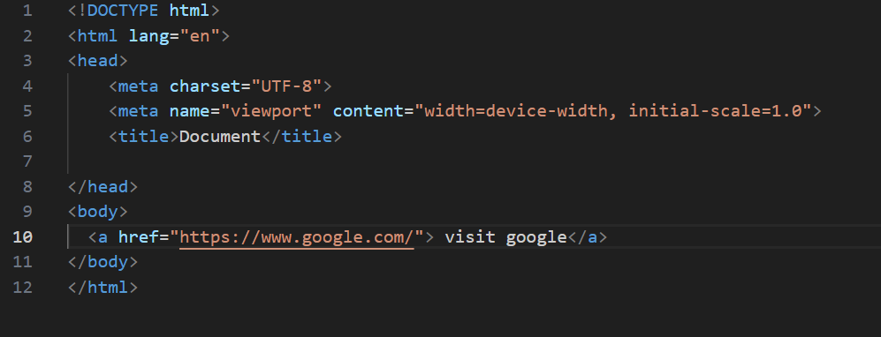



QUE 13 what is the use of I frame tage in html ? with example.

ANS 13 I frame tag is used to embed another document within current html document

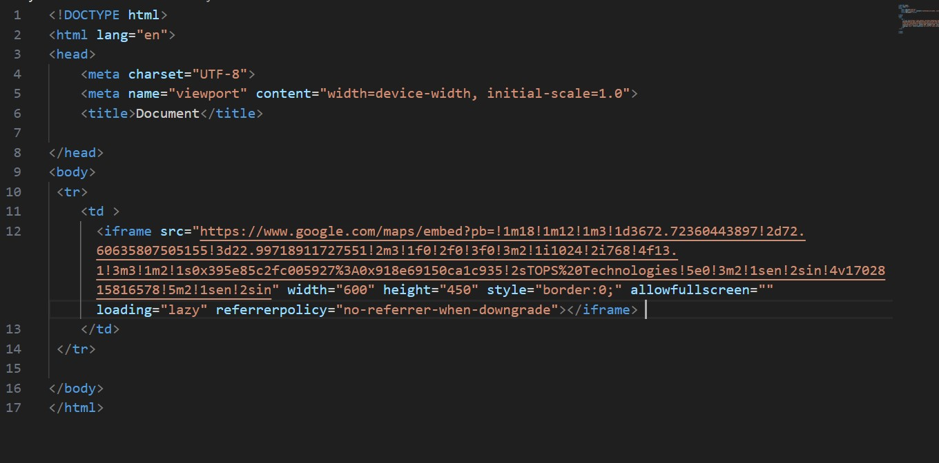

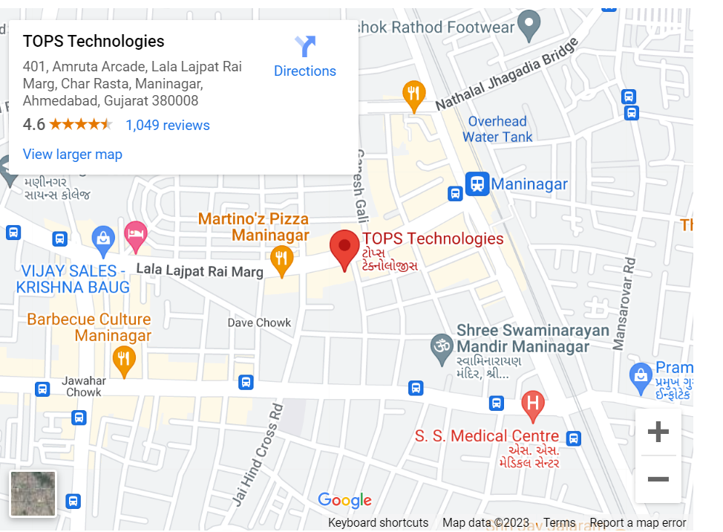

QUE 14 what is the span tag ? with example.

ANS 14 the span tag is a inline element.

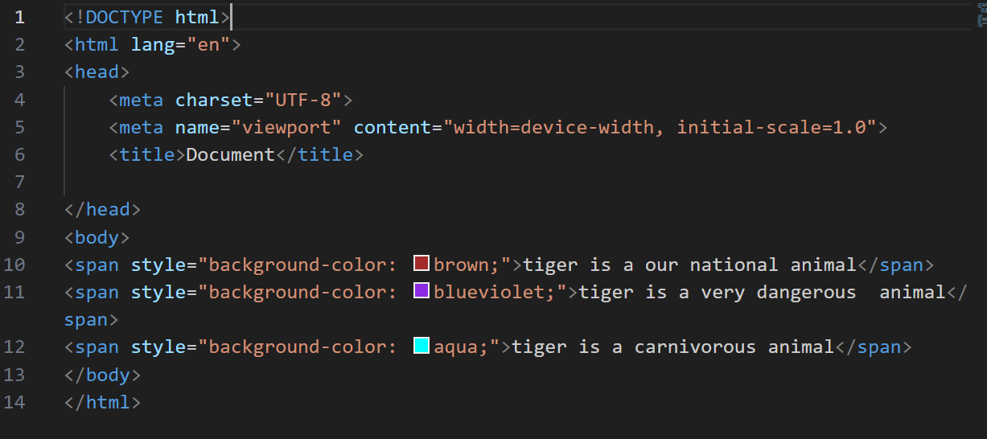



QUE 15 how to insert a picture into a background image of wab page ?with example.

ANS 15 use the back ground image in <div> tag and make a new <div> tag in image tag.

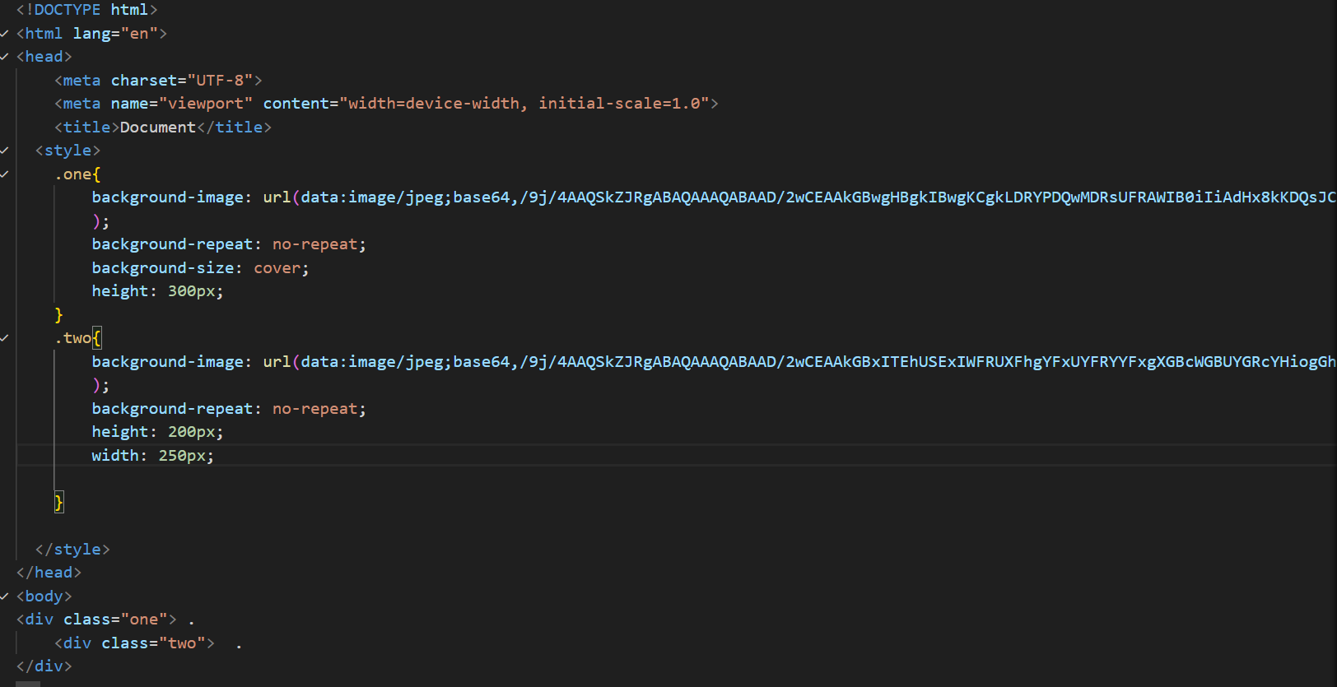



QUE 16 how are active link different from normal links ?

ANS 16 Active link are currently functional and lead to live pages while normal link can refer to any link functional or broken

NORMAL LINK

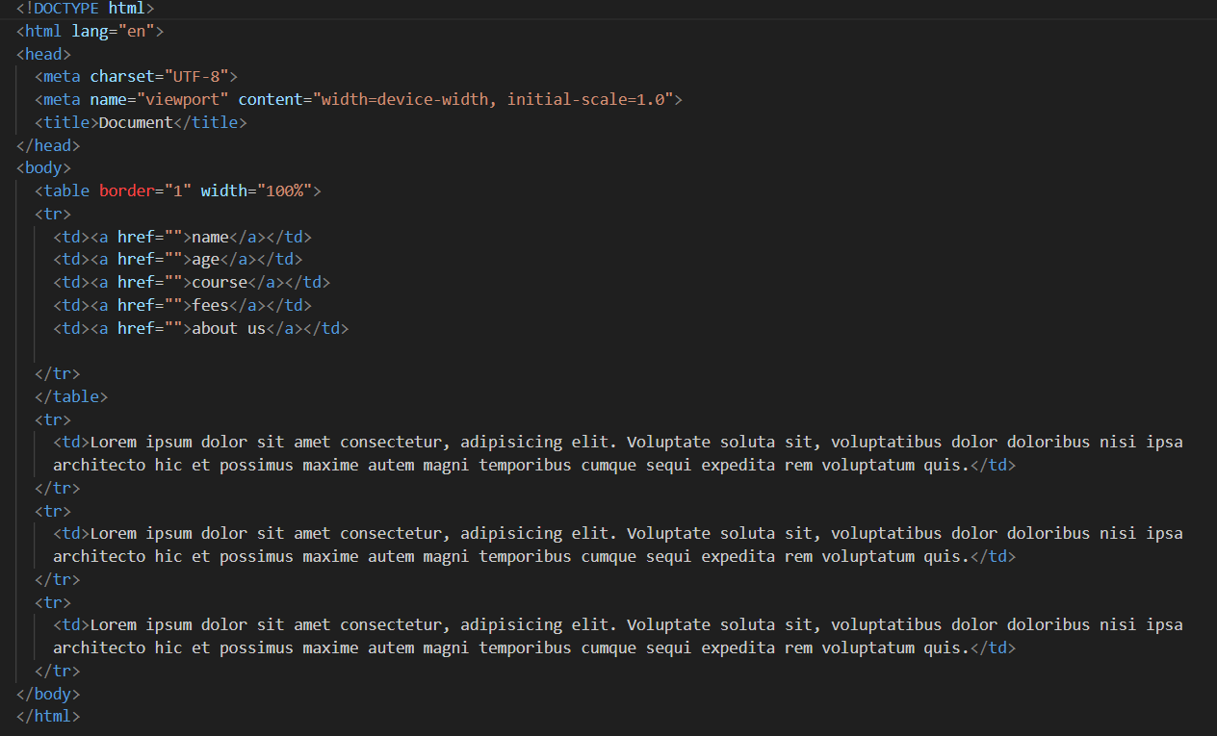

ACTIVE LINK

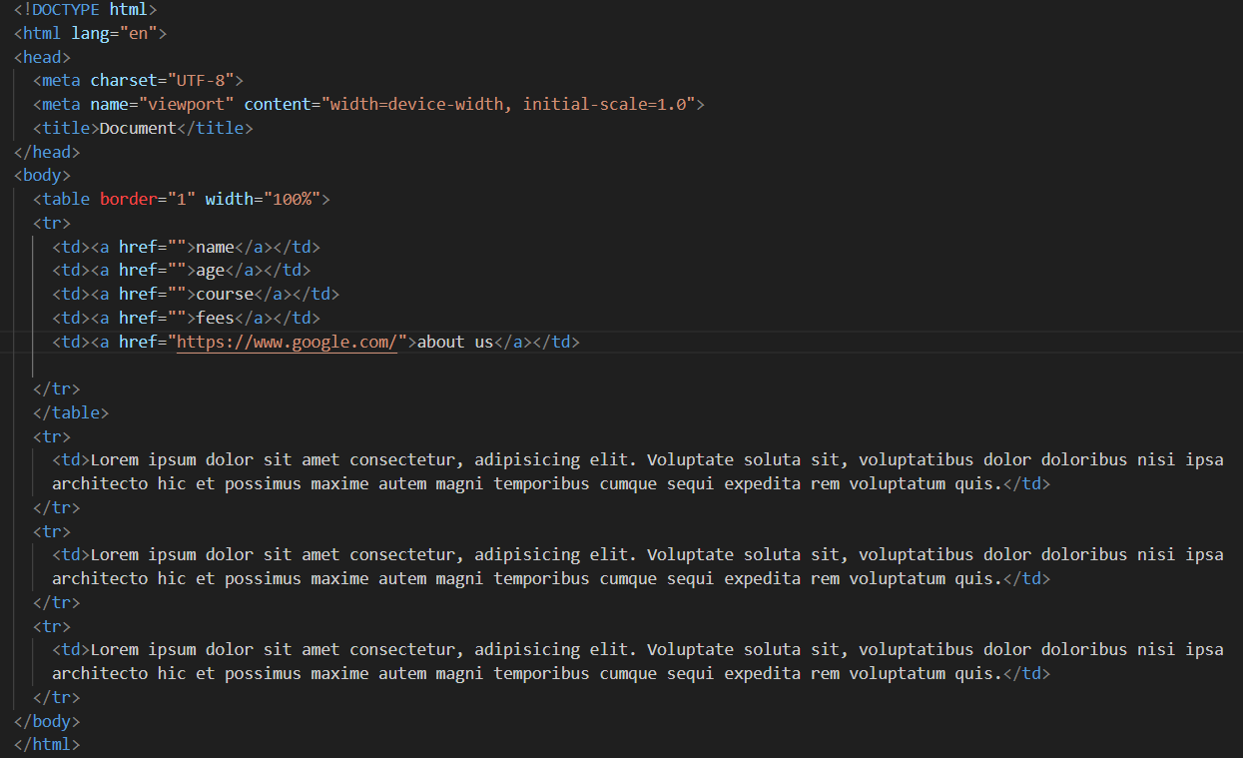

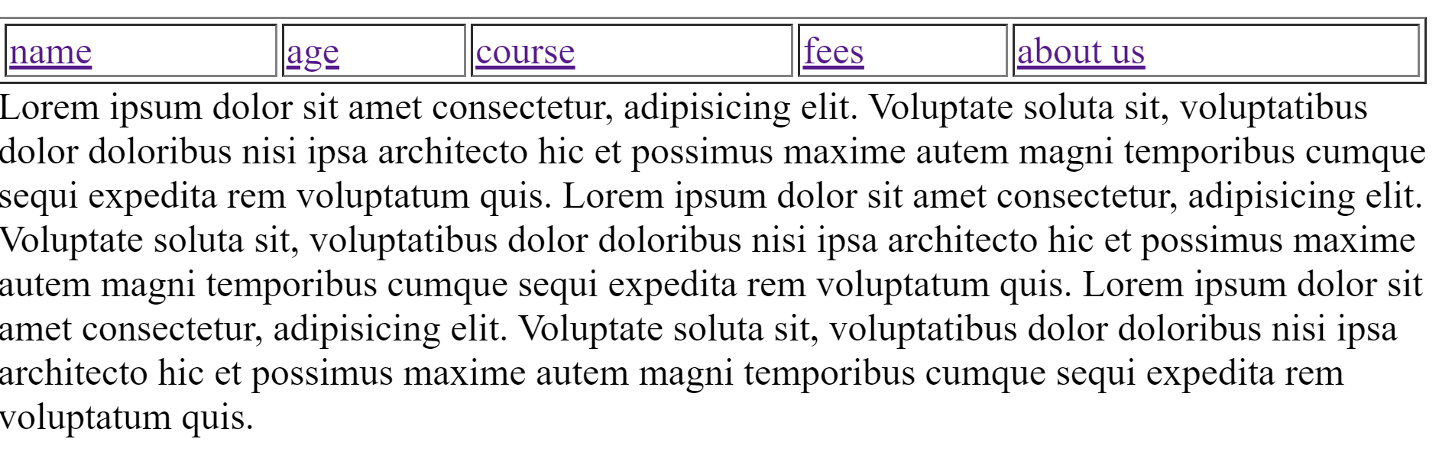



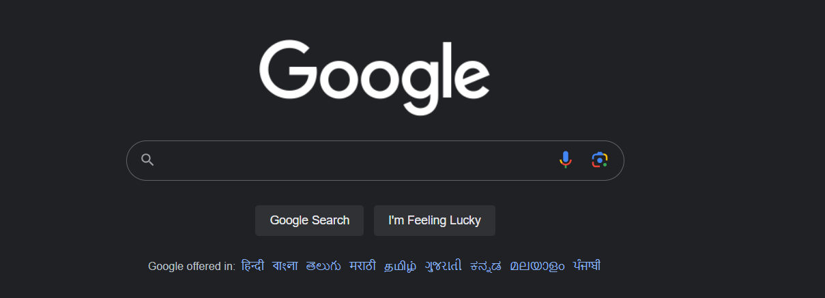

QUE 17 what are the different tags to seprate section of text ?

ANS 17 <br> tag is used to seprete line of tax and break the current line.<p> tag is used in new paragraph.

<p> tag

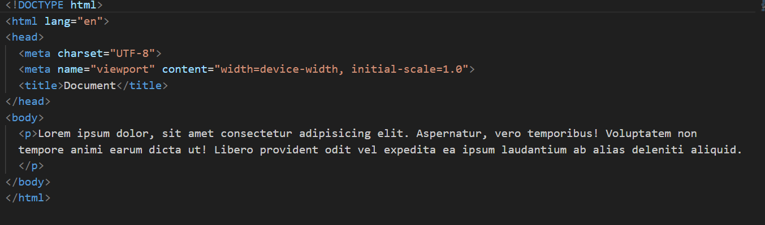

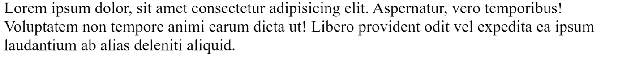

<br> tag

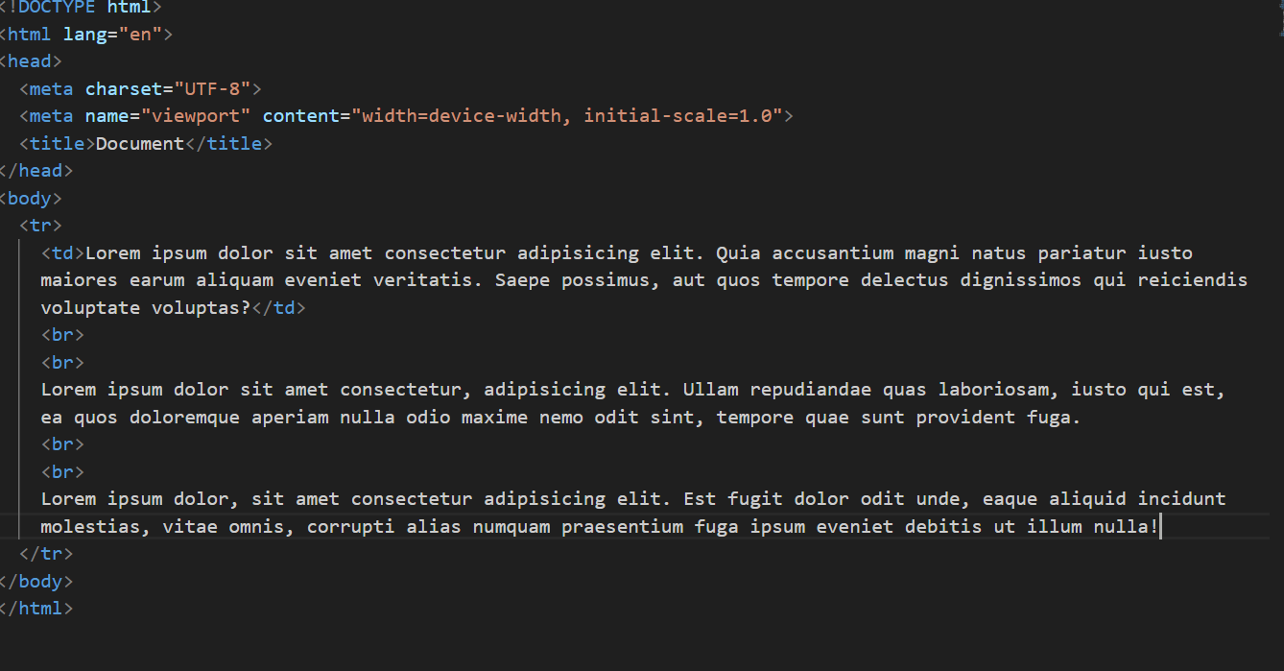

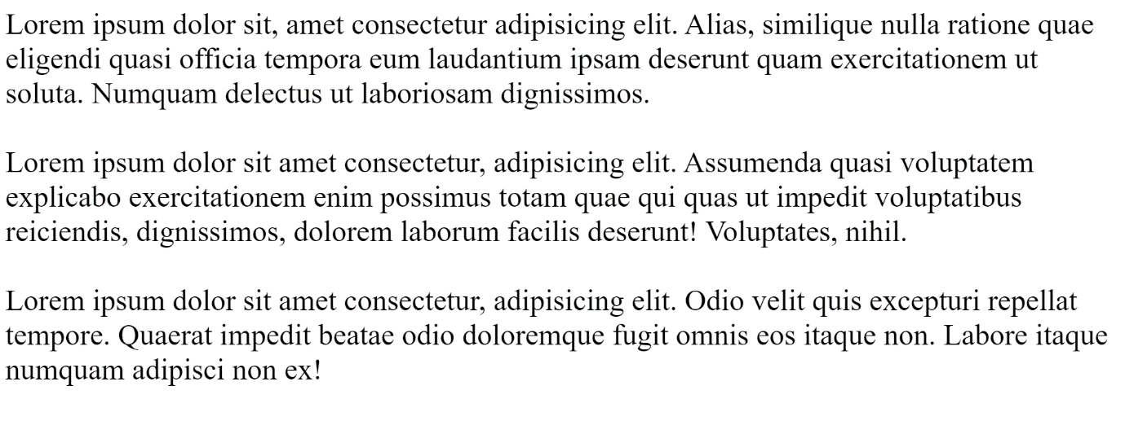

QUE 18 what is svg ?

ANS 18 svg means scable vector graphics.

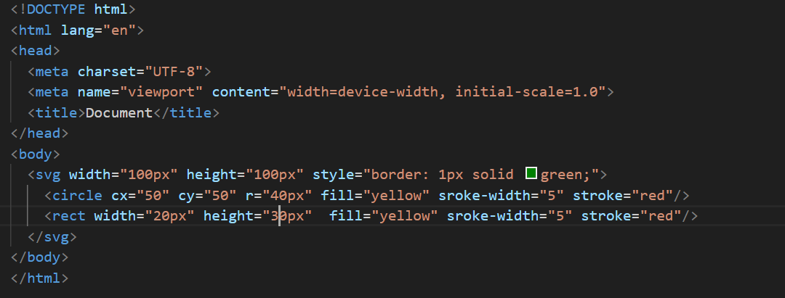

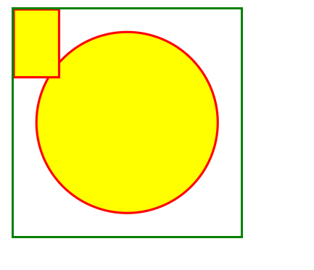

QUE 19 what is a diffrence between HTML and XHTML ?

ANS 19 html: hyper text markup language

Xhtml: extensible hyper text markup language

Html is more lenient in its syntex , while xhtml has a more strict syntex and follow xml rules

Html is a sensitive while xhtml are not sensitive

QUE 20 what are logical and physical tag in html ?

ANS 20 physical and logical tag are used in html for better visibility and understanding

Logical tag

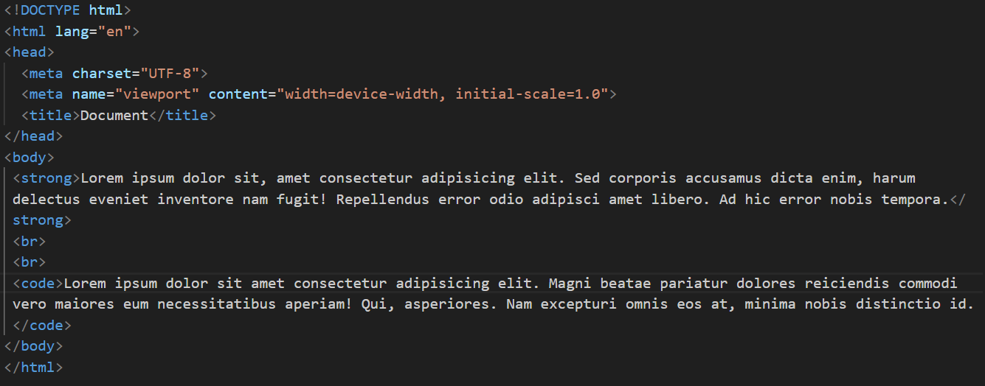

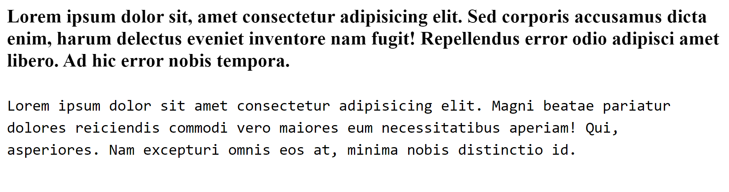

Physical tag

